EXPERIMENT 5

AIM:
Implement Adversarial search for Game playing algorithms.

THEORY:-
The Mini-Max algorithm is a foundational technique in AI game playing, employing recursive traversal of the game tree to anticipate outcomes. In games like Chess or Tic-Tac-Toe, players are designated as MAX, seeking to maximize gains, or MIN, aiming to minimize losses. This approach ensures strategic depth by considering all possible moves and their ramifications, ultimately leading to optimal decision-making. Through its depth-first search methodology, Mini-Max explores the entire game tree, meticulously analyzing potential scenarios.
By accounting for opponent strategies and counter-strategies, it fosters a nuanced understanding of competitive dynamics. Mini-Max's ability to balance risk and reward underscores its significance in facilitating strategic play in two-player games. Its application extends beyond board games to various decision-making scenarios, where optimizing outcomes amidst uncertainty is paramount.

Example Of Min-Max:-

1)Initial Game State:

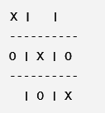

2)Exploration of Game Tree:

At the root level, the player (X) has the option to place their next move in any of the empty cells. We'll explore the possible moves and their resulting game states.
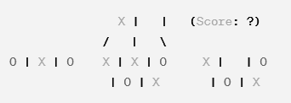

3)Evaluation at Terminal Nodes:

At the terminal nodes (game states where someone wins or the game ends in a draw), we evaluate the state and assign a score.
Terminal Node 1 (Player Wins):
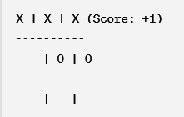
Terminal Node 2 (Opponent Wins):
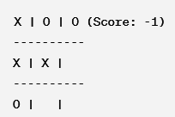
Terminal Node 3 (Draw):
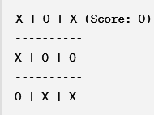

4)Backtracking and Decision:

Once we've evaluated the terminal nodes, we backtrack through the tree, propagating the scores up to the root node.
At each level, we select the move that leads to the best outcome for the player (X) if it's their turn or the worst outcome for the opponent (O) if it's their turn.
Finally, we select the move that yields the highest score at the root node, which represents the optimal move for the player (X).

Problems of Min-Max Algorithm:

- Exponential Complexity: Mini-Max's time complexity grows exponentially with the depth of the game tree impractical for games with large branching factors

- Memory Intensive: Storing and traversing the entire game tree demands significant memory resources, limiting its application to games with small state spaces.

- Limited Lookahead: Due to computational constraints, Mini-Max may not explore the entire game tree to the desired depth, potentially leading to suboptimal moves.

- Assumption of Perfect Play: Mini-Max assumes both players make optimal moves, which doesn't reflect real-world scenarios where opponents may act suboptimally or unpredictably.

- Incompatibility with Uncertainty: Mini-Max operates under perfect information assumptions, making it less suitable for games with incomplete information.

Properties of Min-Max algorithm:
- Complete- Min-Max algorithm is Complete. It will definitely find a solution (if it exists), in the finite search tree.
- Optimal- Min-Max algorithm is optimal if both opponents are playing optimally.
- Time complexity- As it performs DFS for the game-tree, so the time complexity of Min-Max algorithm is O(b^{m}), where b is the branching factor of the game-tree, and m is the maximum depth of the tree.
- Space Complexity- Space complexity of Min-max algorithm is also similar to DFS which is O(bm).
Advantages
- A thorough assessment of the search space is performed.
- Decision making in AI is easily possible.
- New and smart machines are developed with this algorithm.
Code-
import random
def print_board(board):
for row in board:
print(" | ".join(row))
print("-" * 5)

def check_winner(board):
for i in range(3):
if all(board[i][j] == board[i][0] and board[i][0] != ' ' for j in range(3)):
return board[i][0]
if all(board[j][i] == board[0][i] and board[0][i] != ' ' for j in range(3)):
return board[0][i]

if all(board[i][i] == board[0][0] and board[0][0] != ' ' for i in range(3)):
return board[0][0]
if all(board[i][2 - i] == board[0][2] and board[0][2] != ' ' for i in range(3)):
return board[0][2]
return None

def is_board_full(board):
return all(board[i][j] != ' ' for i in range(3) for j in range(3))

def get_available_moves(board):
return [(i, j) for i in range(3) for j in range(3) if board[i][j] == ' ']

def opponent_move(board):
available_moves = get_available_moves(board)
return random.choice(available_moves)

def tic_tac_toe():
board = [[' ' for _ in range(3)] for _ in range(3)]
current_player = 'X'

while True:
print_board(board)

if current_player == 'X':
row = int(input(f"Player X, enter the row (0, 1, or 2): "))
col = int(input(f"Player X, enter the column (0, 1, or 2): "))
else:
print("Player O (Computer) is making a move...")
row, col = opponent_move(board)
print(f"Player O chooses row {row} and column {col}")

if 0 <= row < 3 and 0 <= col < 3 and board[row][col] == ' ':
board[row][col] = current_player
winner = check_winner(board)

if winner:
print_board(board)
print(f"Player {winner} wins!")
break
elif is_board_full(board):
print_board(board)
print("It's a tie!")
break

current_player = 'O' if current_player == 'X' else 'X'
else:
print("Invalid move. Try again.")

if __name__ == "__main__":
tic_tac_toe()

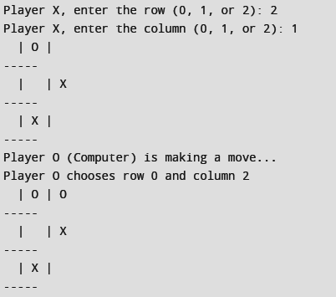
Output-
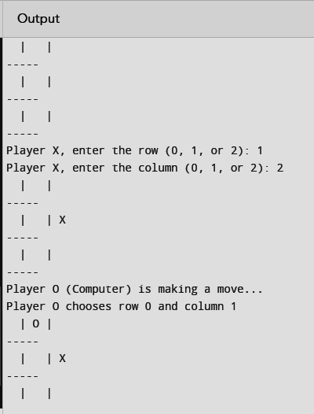

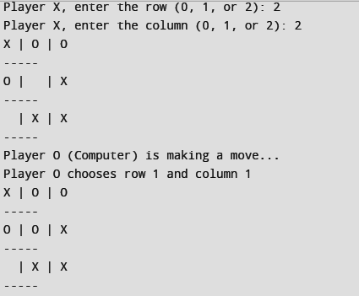
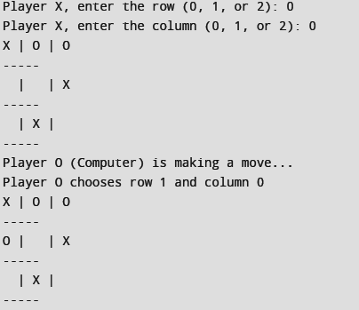

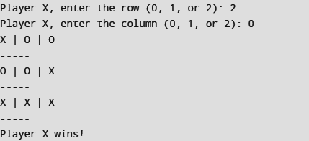

Conclusion:-
In conclusion, this code provides an interactive implementation of Tic-Tac-Toe where users can play against an AI opponent. The AI utilizes the Mini-Max algorithm to make strategic decisions, aiming to win or draw the game whenever possible. By allowing users to input their moves and displaying the current state of the board, the code provides an engaging and challenging gaming experience. With its emphasis on optimal decision-making and strategic gameplay, this implementation offers both entertainment and opportunities for players to improve their skills in the classic game of Tic-Tac-Toe.

